DAY – 1

Document Version: 1.0

Date: 26/01/2026

DAY: MONDAY

Prepared By: Testing & Documentation Team

UI COMPONENTS TEAM:

MODULE 5: TIME TRACKING

Introduction:
Time tracking in UI components involves measuring the time users spend interacting with different interface elements. It helps analyze user behavior, evaluate performance, and improve the overall user experience.
SCREENSHOT: 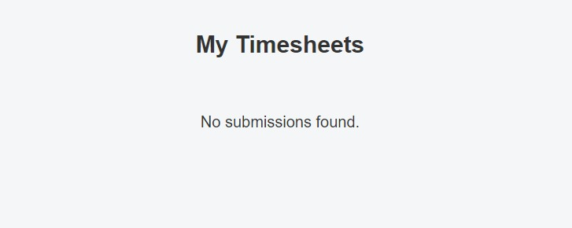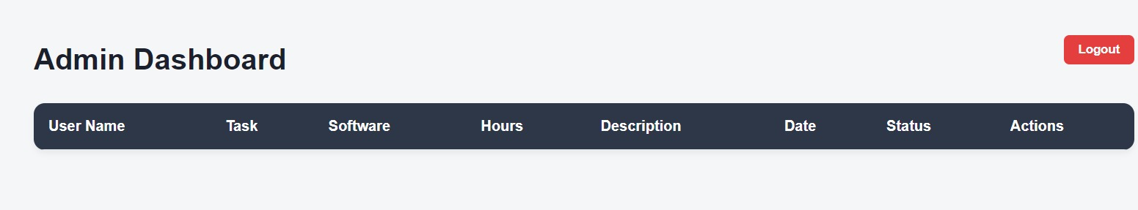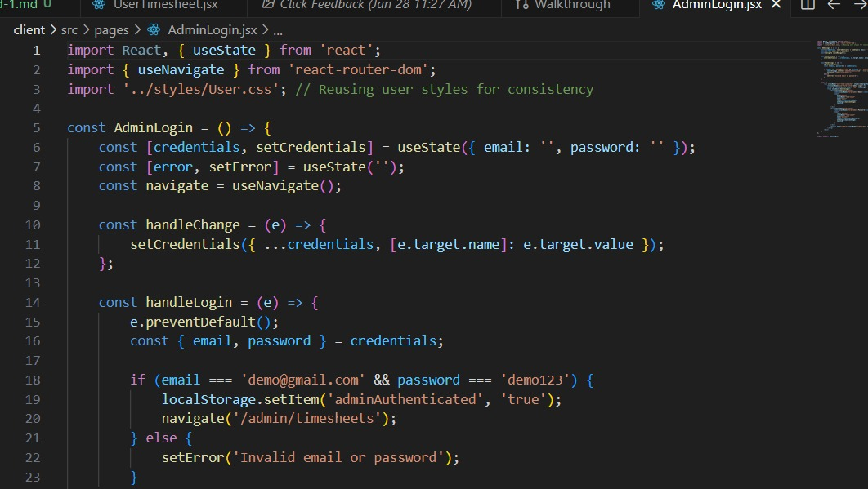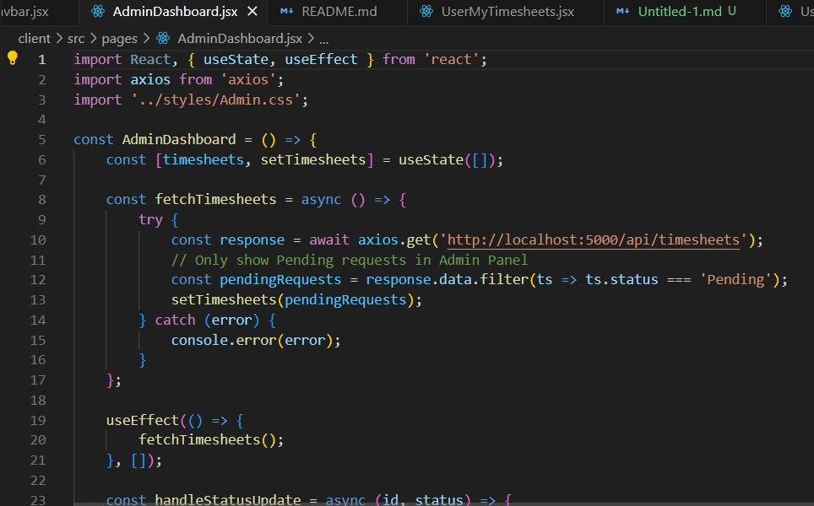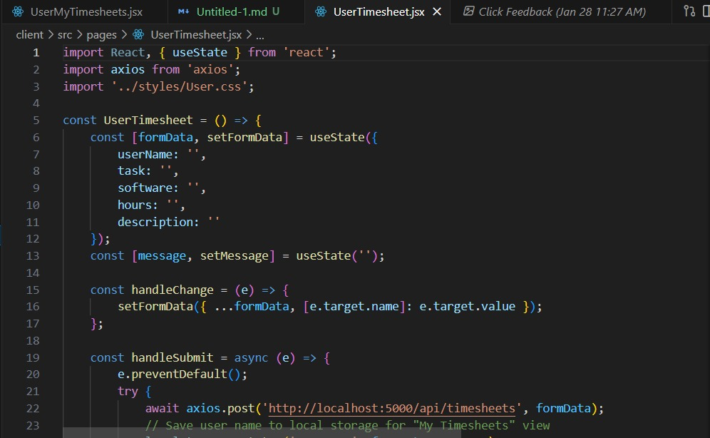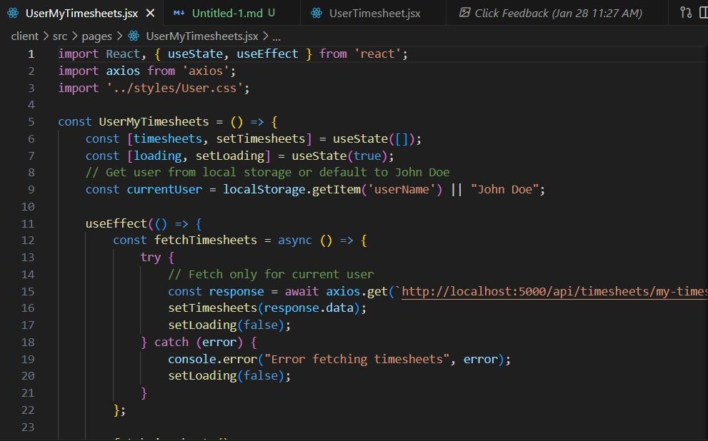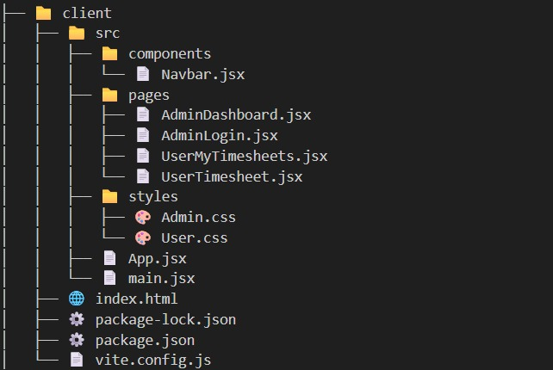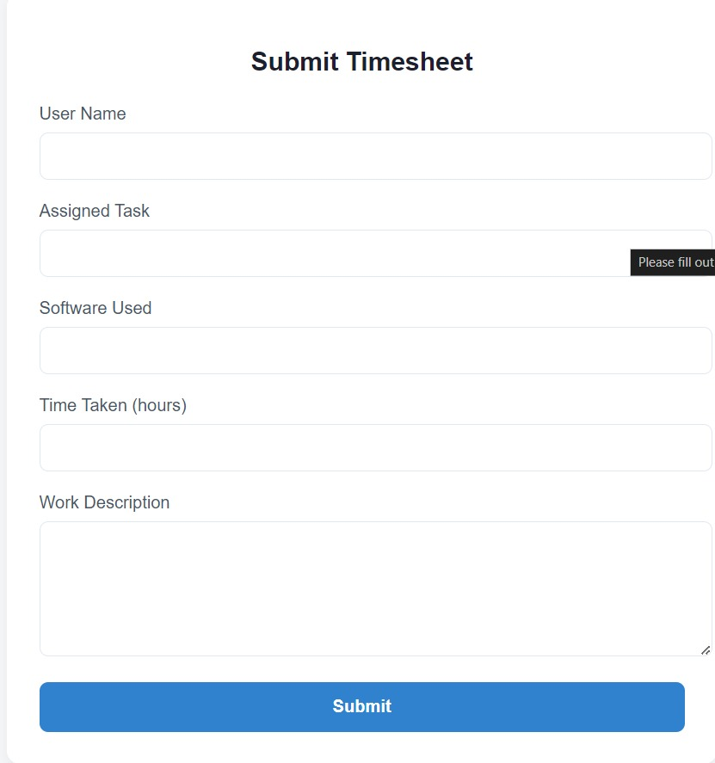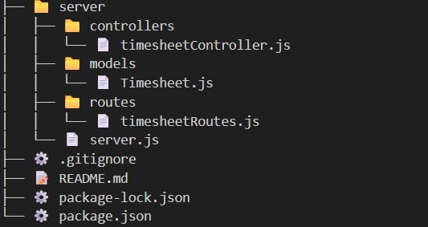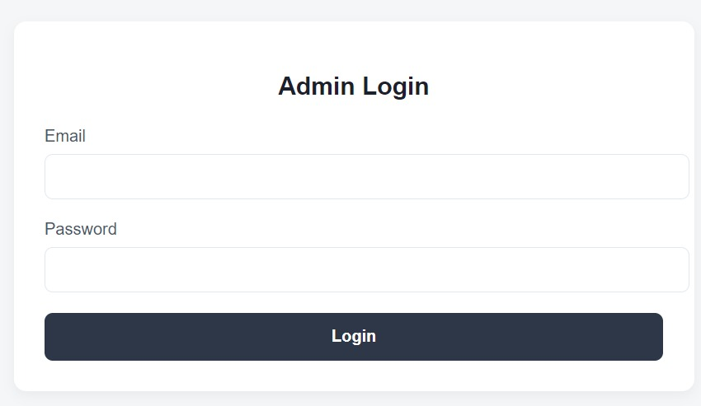

MODULE 6: COLLABRATION & COMMUNICATION

Introduction:
Collaboration and communication in UI components enable users to interact, share information, and work together within an application. These components support features such as messaging, notifications, shared views, and real-time updates, helping improve teamwork, coordination, and overall user engagement.
SCREENSHOT: PENDING
Description: PENDING

DASHBOARD DEVELOPMENT TEAM:

MODULE 2: PROJECT MANAGEMENT

Introduction:
Project management in dashboard development involves planning, organizing, and monitoring tasks to ensure the project is completed on time and meets requirements. The dashboard helps track progress, manage resources, and provide a clear overview of project activities.
SCREENSHOT: PENDING
Description: PENDING

MODULE 4: MILESTONE & PHASES

Introduction:
Milestones and phases in dashboard development represent key stages and important goals of the project. They help track progress, organize work, and ensure the project moves forward in a planned and structured manner.
SCREENSHOT: 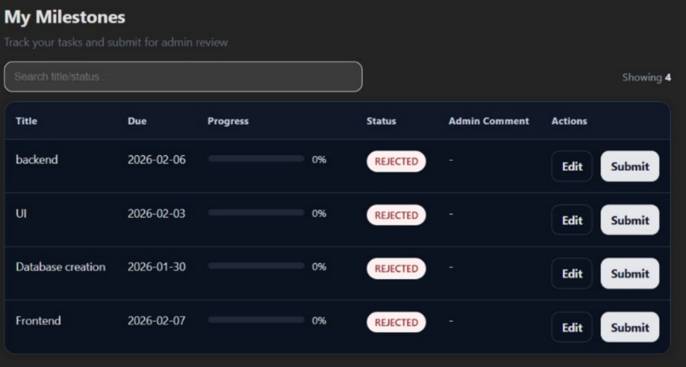

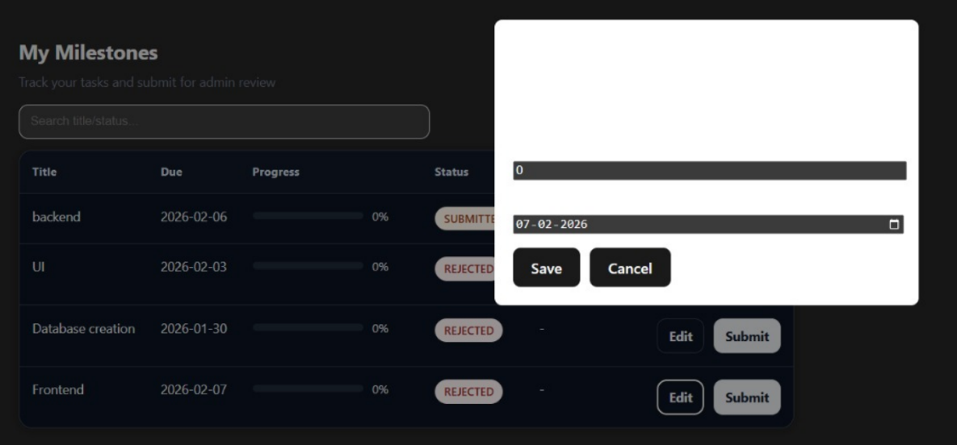
Description: Milestone Creation
Milestones were created for all team members in the dashboard system.
Tasks like UI, frontend, backend, and database were added with due dates.
This helps the team track work progress and submit tasks for admin review.

TASK MANAGEMENT TEAM:

MODULE 7: ISSUE & BUG TRACKING:

Introduction:
Issue and bug tracking in task management involves identifying, recording, and resolving problems that occur during project execution. It helps teams monitor issues, assign responsibilities, and ensure timely fixes for smooth project progress.
SCREENSHOT: PENDING
Description: PENDING

MODULE 12: DASHBOARD VIEWS

Introduction:
Dashboard views in task management provide a clear and organized display of tasks, progress, and status updates. They help users quickly understand project information and manage work efficiently.
SCREENSHOT:
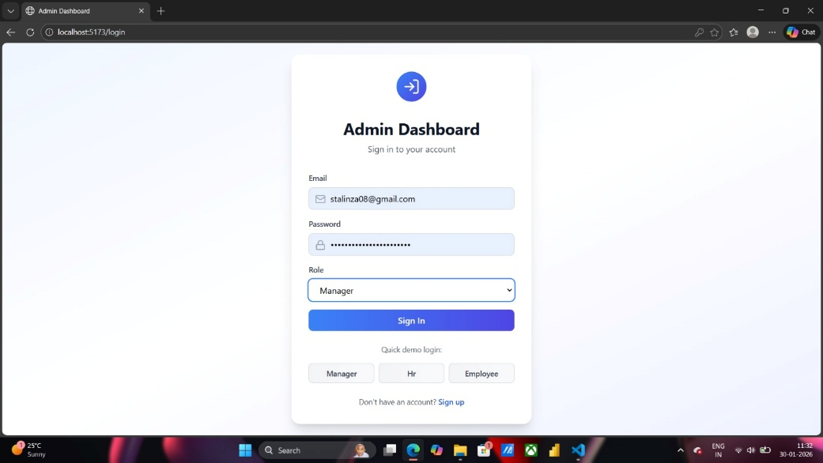
Description: Login Validation
Login validation was implemented for the Task Management Dashboard. The system verifies user credentials (email and password) along with role selection (Manager, HR, Employee). Only valid users are allowed to access the dashboard based on their assigned role, ensuring secure and role-based access control. Invalid login attempts are restricted to maintain application security.

FEATURES:
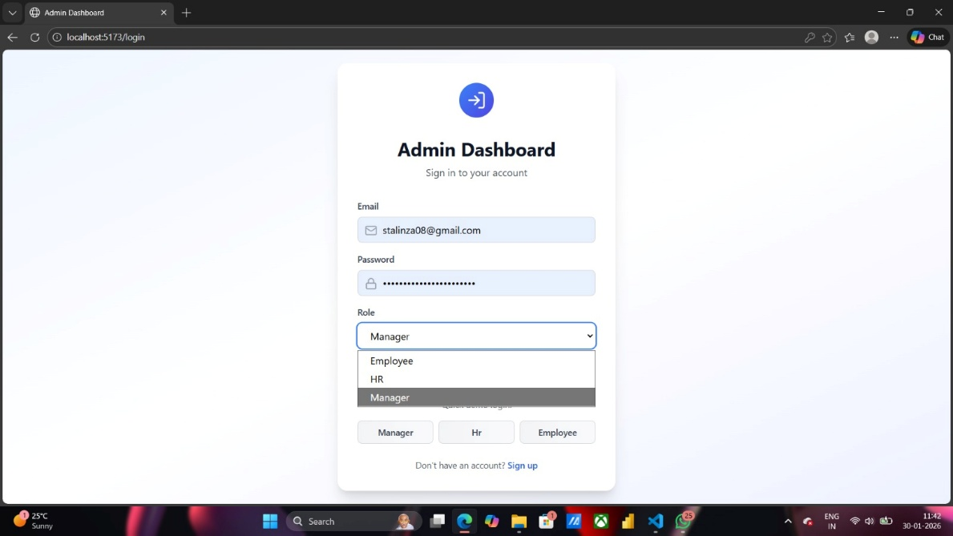
Login validation:
Individual user can login based on the user role (Employee,Hr,Manager).
The login validation verifies the user’s id/name and the respective credentials and then allows the user to enter into the dashboard to check their tasks

ANALYTICS & REPORT TEAM:

MODULE 9: REPORT & ANALYTICS:

Introduction:
Reports and analytics provide meaningful insights by collecting and analyzing project data. They help track performance, identify trends, and support better decision-making through clear visual and statistical information.
SCREENSHOT: PENDING
Description: PENDING

MODULE 10: NOTIFICATION & ALERTS

Introduction:
Notifications and alerts in analytics and reports inform users about important updates, changes, or critical events. They help ensure timely awareness and quick action based on data insights.
SCREENSHOT: PENDING
Description: PENDING

DESIGN & UX TEAM:

MODULE 1: AUTHENTICATION & ORGANIZATION:

Introduction:
Authentication and organization setup in design and UX ensure secure access and proper user management within the application. They help users sign in safely, define roles, and organize teams for a smooth and consistent user experience.

SCREENSHOT:
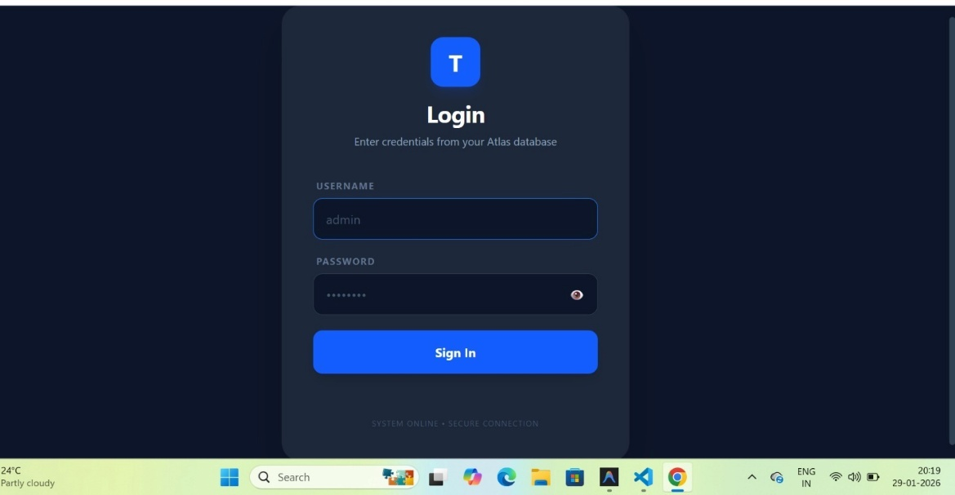
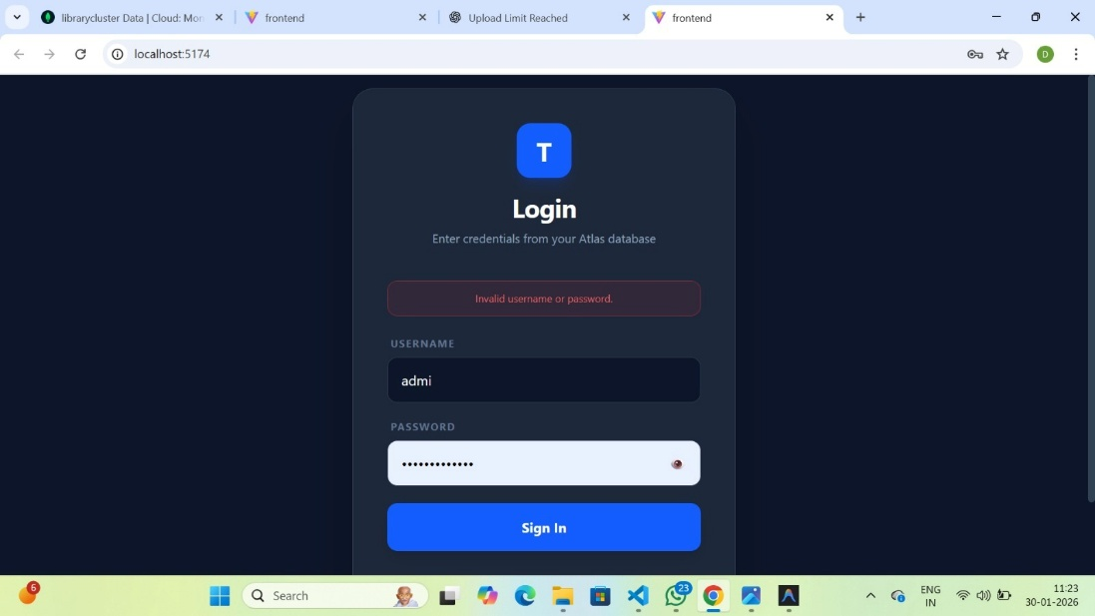
Description: developed the authentication module by creating a responsive login interface using vite + react. Implemented client-side validation to handle incorrect login attempts, with real-time pop-up alerts displayed for invalid username or password entries.
Pending work:
integration of backend services, including mongodb atlas connection and server-side credential validation, to enable secure and complete authentication functionality

MODULE 10: TASK MANAGEMENT

Introduction:
Task management in design and UX focuses on organizing, assigning, and tracking tasks in a user-friendly manner. It helps users plan work efficiently and ensures a smooth and intuitive experience.
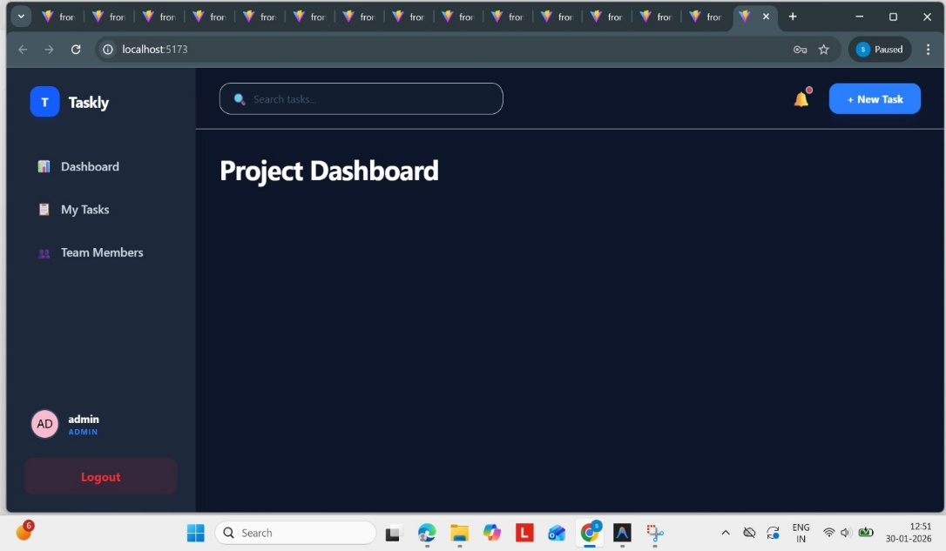

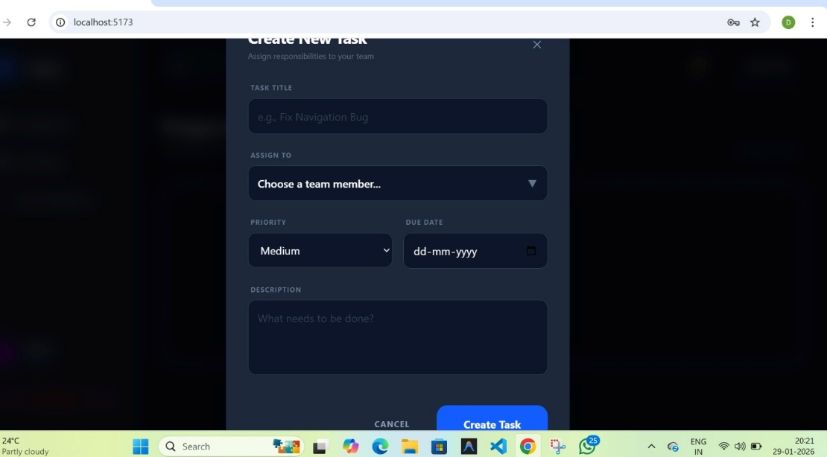

Description: Designed and developed the Create Task page as part of the Task Management module. Implemented input fields to capture task name, description, priority, and due date, enabling users to create tasks efficiently.
Integrated frontend functionality to send task details to the backend, with successful storage handled through Node.js and MongoDB Atlas. The user interface was built using React with Vite and styled using CSS to ensure a clean and user-friendly experience.
Pending Work:
Completion of the authentication mechanism and implementation of role-based access control to restrict task creation based on user roles.

